Nicole & Philip Sampson
224 Tanglewood
Marion, KS 66861
REGISTRATION FORM
Open for all youth in grades 6-8th for the Jr. High Rally April 12th -14th 2019

Name:________________________________________ Grade:___________________________
Address:____________________________________City:________________________________
Zip:___________________________________Phone:___________________________________
Home Church:___________________________________________________________________
Parent email:____________________________________________________________________
Youth email:_____________________________________________________________________
Special dietary needs:_____________________________________________________________
Emergency Contact:_________________________________Phone:_________________________
Please provide information if your child has any special needs or accommodations secondary to an illness or disability:____________________________________________________________________

Emergency Medical Information (required)-Please send a copy of youth’s insurance card (front and back), and any other medical information that we might need for your youth. All medications must be in a zip-lock bag with instructions and dosage to be provided to Nicole at the start of the rally.

Include with this form a check for $10 per youth (if more than one child per family, the fee will be $5 per youth): Check #__________ # of youth:__________ Total Amount enclosed:__________
Please make checks payable to Western Plains District Youth and write “Jr. High Rally” in the memo area of your check.

Upon signing this form, you are allowing your youth to come and participate in the Jr. High Rally and take part in activities outside of the Hutchinson Community Church of the Brethren property and within the community (allowing advisors to transport your youth to and from the Hutchinson Church and activities).

Note: It is the parents and/or guardian’s responsibility to find transportation to and from the rally.

Parent/Guardian Signature:
___________________________________________________________________
Registration Deadline: April 5th 2019
Mail this form, Insurance card copies, and payment to:
Nicole Sampson 224 Tanglewood Marion, KS 66861

2019 Jr. High Rally
Digging Deeper- Seeking Treasure
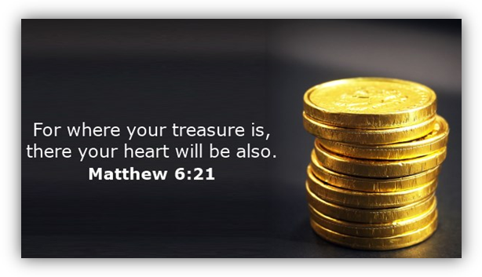
Who: All WPD Jr. High Youth (6-8th grades)
What: Jr. High Rally
When: April 12th -14th, 2019
Friday, 6PM until Sunday, Noon
Where: Community Church of the Brethren,
Hutchinson, KS
Why: To connect, grow, and dig deeper into our faith journey
Come and enjoy a weekend focused on DIGGING DEEPER and FINDING TREASURES. Come and discover how we can find out what is beneath the surface of faith, Christianity, Jesus, and ourselves. The weekend will be full of lots of fun, time outdoors, devotions, movies, and more! We hope you can make it! We may even search for buried treasure.
“The Word of God is a treasure map. That treasure map is the most valuable thing you have until you get to that treasure.” Eric Ludy

District Jr. High Coordinators
Nicole & Philip Sampson
224 Tanglewood
Marion, KS 66861
wpdcoordinators@gmail.com
(620) 966-6454
Call or Text

